**LifeCycle**

Исходный код проекта:

<https://github.com/verkhoumov/AndroidLabs/tree/master/LifeCycle>

Скриншоты экрана:

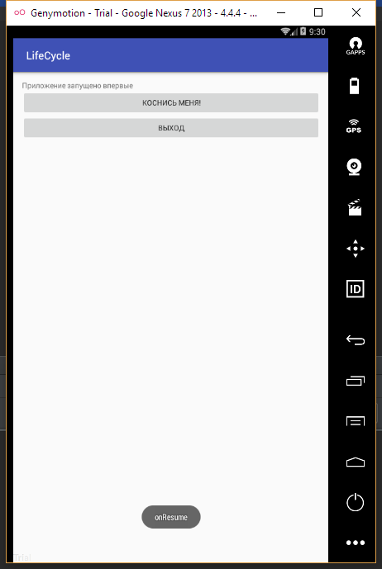

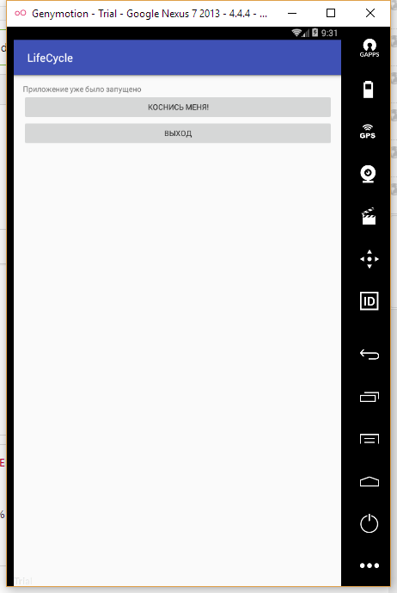

Исходный код.

MainActivity.java:

1. **package** ru.verkhoumov.lifecycle;
3. **import** android.support.v7.app.AppCompatActivity;
4. **import** android.os.Bundle;
5. **import** android.util.Log;
6. **import** android.view.View;
7. **import** android.widget.TextView;
8. **import** android.widget.Toast;
10. **public** **class** MainActivity **extends** AppCompatActivity {
11. **private** String TAG = "LifeCycle";
12. **private** TextView mInfoLog;
14. @Override
15. **protected** **void** onCreate(Bundle savedInstanceState) {
16. **super**.onCreate(savedInstanceState);
17. setContentView(R.layout.activity_main);
19. mInfoLog = (TextView) findViewById(R.id.textView);
20. Toast
21. .makeText(getApplicationContext(), "onCreate", Toast.LENGTH_LONG)
22. .show();
23. Log.i(TAG, "onCreate()");
24. }
26. @Override
27. **protected** **void** onStart() {
28. **super**.onStart();
29. Toast
30. .makeText(getApplicationContext(), "onStart", Toast.LENGTH_LONG)
31. .show();
32. Log.i(TAG, "onStart()");
33. }
35. @Override
36. **protected** **void** onResume() {
37. **super**.onResume();
38. Toast
39. .makeText(getApplicationContext(), "onResume", Toast.LENGTH_LONG)
40. .show();
41. Log.i(TAG, "onResume()");
42. }
44. @Override
45. **protected** **void** onPause() {
46. **super**.onPause();
47. Toast
48. .makeText(getApplicationContext(), "onPause", Toast.LENGTH_LONG)
49. .show();
50. Log.i(TAG, "onPause()");
51. }
53. @Override
54. **protected** **void** onStop() {
55. **super**.onStop();
56. Toast
57. .makeText(getApplicationContext(), "onStop", Toast.LENGTH_LONG)
58. .show();
59. Log.i(TAG, "onStop()");
60. }
62. @Override
63. **protected** **void** onRestart() {
64. **super**.onRestart();
65. Toast
66. .makeText(getApplicationContext(), "onRestart", Toast.LENGTH_LONG)
67. .show();
68. Log.i(TAG, "onRestart()");
69. }
71. @Override
72. **protected** **void** onDestroy() {
73. **super**.onDestroy();
74. Toast
75. .makeText(getApplicationContext(), "onDestroy", Toast.LENGTH_LONG)
76. .show();
77. Log.i(TAG, "onDestroy()");
78. }
80. *// Нажатие на кнопки.*
81. **public** **void** onClick(View v) {
82. **switch** (v.getId()) {
83. **case** R.id.touchMe:
84. mInfoLog.setText("Приложение уже было запущено");
85. **break**;
86. **case** R.id.exit:
87. finish();
88. **break**;
89. **default**:
90. **break**;
91. }
92. }
93. }

activity_main.xml:

1. **<?xml** version="1.0" encoding="utf-8"**?>**
2. **<LinearLayout** xmlns:android="http://schemas.android.com/apk/res/android"
3. xmlns:tools="http://schemas.android.com/tools"
4. android:id="@+id/activity_main"
5. android:layout_width="match_parent"
6. android:layout_height="match_parent"
7. android:paddingBottom="@dimen/activity_vertical_margin"
8. android:paddingLeft="@dimen/activity_horizontal_margin"
9. android:paddingRight="@dimen/activity_horizontal_margin"
10. android:paddingTop="@dimen/activity_vertical_margin"
11. android:orientation="vertical"
12. tools:context="ru.verkhoumov.lifecycle.MainActivity"**>**
14. **<TextView**
15. android:layout_width="match_parent"
16. android:layout_height="wrap_content"
17. android:text="@string/first_startup"
18. android:id="@+id/textView" **/>**
20. **<Button**
21. android:layout_width="match_parent"
22. android:layout_height="wrap_content"
23. android:id="@+id/touchMe"
24. android:onClick="onClick"
25. android:text="@string/touch_me" **/>**
27. **<Button**
28. android:layout_width="match_parent"
29. android:layout_height="wrap_content"
30. android:id="@+id/exit"
31. android:onClick="onClick"
32. android:text="@string/exit" **/>**
33. **</LinearLayout>**

strings.xml:

1. **<resources>**
2. **<string** name="app_name"**>**LifeCycle**</string>**
3. **<string** name="first_startup"**>**Приложение запущено впервые**</string>**
4. **<string** name="touch_me"**>**Коснись меня!**</string>**
5. **<string** name="exit"**>**Выход**</string>**
6. **</resources>**